ASSIGNMENT 6.4:

Titanic Data Analysis:

Write a MapReduce program to find out number of males and females died in the titanic tragedy and save the output in Key Value Output format.

Driver Class :

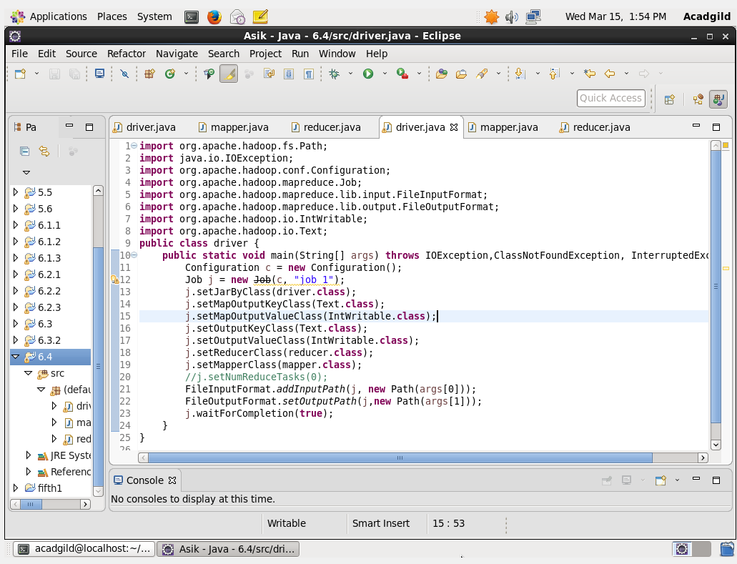

Mapper Class :

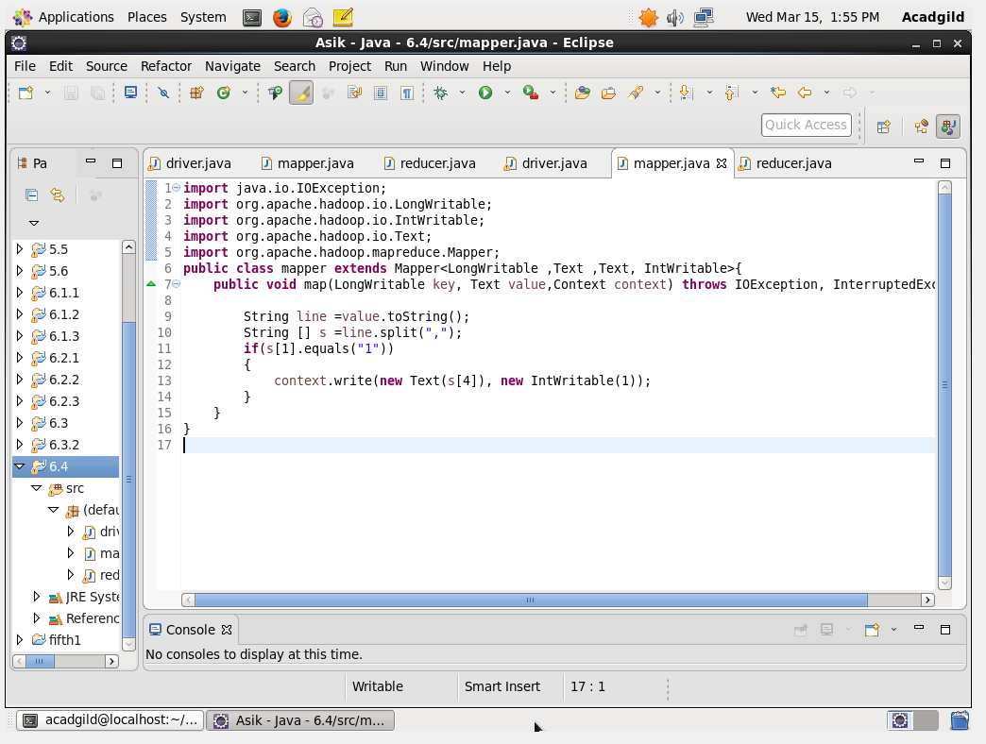

Reducer Class :

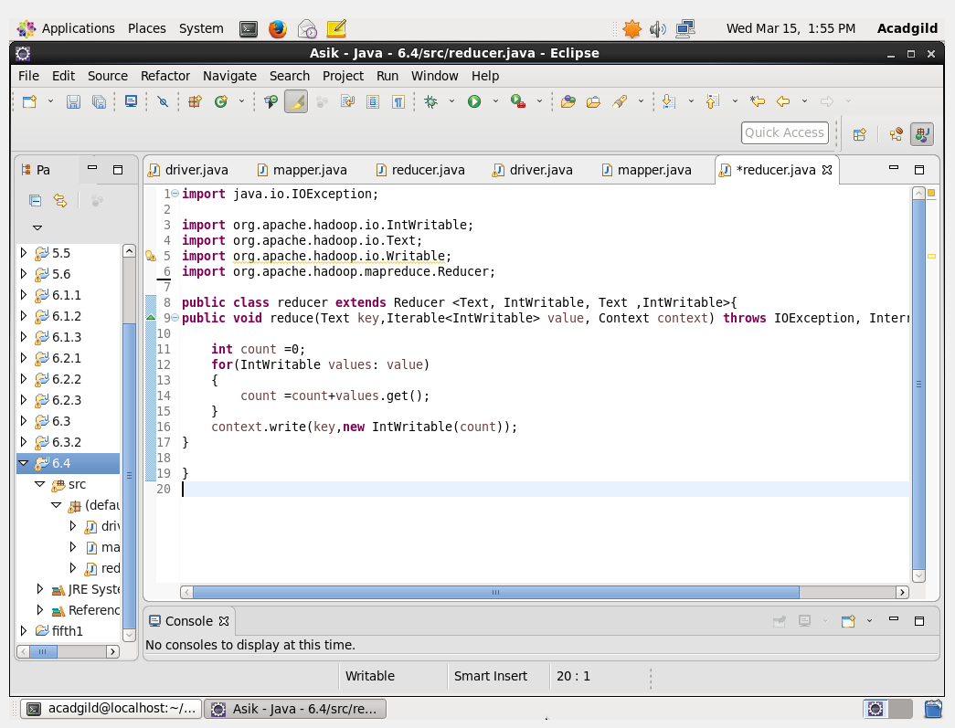

Output:

